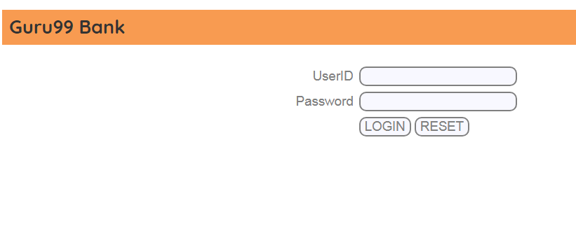**HomePage**

package pages;

import [org.openqa.selenium.By](http://org.openqa.selenium.by/);

import org.openqa.selenium.WebDriver;

public class **HomePage** {

WebDriver driver;

By **homePageUserName** = By.xpath("//table//tr[@class='heading3']");

public HomePage(WebDriver driver){

this.driver = driver;

}

//Get the User name from Home Page

public String **getHomePageDashboardUserName()**{

return driver.findElement(homePageUserName).getText();

}

}

**LoginPage**

package pages;

import org.openqa.selenium.By;

import org.openqa.selenium.WebDriver;

public class **LoginPage** {

WebDriver driver;

By user99GuruName = By.name("uid");

By password99Guru = By.name("password");

**By titleText =By.className("barone");**

**<h2 class="barone" style="font-size:27px;font-weight:700;padding: 10px;">Guru99 Bank</h2>**

By login = By.name("btnLogin");

public LoginPage(WebDriver driver){

this.driver = driver;

}

//Set user name in textbox

public void **setUserName(String strUserName)**{

driver.findElement(user99GuruName).sendKeys(strUserName);

}

//Set password in password textbox

public void **setPassword(String strPassword)**{

driver.findElement(password99Guru).sendKeys(strPassword);

}

//Click on login button

public void **clickLogin()**{

driver.findElement(login).click();

}

//Get the title of Login Page

**public String getLoginTitle(){**

**return driver.findElement(titleText).getText();**

**}**

/**

* This POM method will be exposed in test case to login in the application

* @param strUserName

* @param strPasword

* @return

*/

public void l**oginToGuru99(String strUserName,String strPasword)**{

//Fill user name

this.setUserName(strUserName);

//Fill password

this.setPassword(strPasword);

//Click Login button

this.clickLogin();

}

}

**TEST CLASS**

package SelPackage;

import java.util.concurrent.TimeUnit;

import org.openqa.selenium.WebDriver;

import org.testng.Assert;

import org.testng.annotations.BeforeTest;

import org.testng.annotations.Test;

import pages.LoginPage;

import pages.HomePage;

import org.openqa.selenium.chrome.ChromeDriver;

public class SeleniumClass {

//comment the above line and uncomment below line to use Chrome

**@Test**

**public void test()**

**{**

WebDriver driver;

**LoginPage objLogin**;

**HomePage objHomePage**;

System.setProperty("webdriver.chrome.driver","C:\\ChromeDriver\\chromedriver.exe");

driver = new ChromeDriver();

**driver.manage().timeouts().implicitlyWait(10, TimeUnit.SECONDS);**

**driver.get("http://demo.guru99.com/V4/");**

//Create Login Page object

**objLogin** = new LoginPage(driver);

**//Verify login page title**

String **loginPageTitle** = objLogin.**getLoginTitle();**

**Assert.assertTrue**(**loginPageTitle**.toLowerCase().contains("guru99 bank"));



**<h2 class="barone" style="font-size:27px;font-weight:700;padding: 10px;">Guru99 Bank</h2>**

//login to application

objLogin.**loginToGuru99**("mgr123", "mgr!23");

// go the next page

**objHomePage** = new HomePage(**driver**);

**//Verify home page**

**Assert.assertTrue**(objHomePage.**getHomePageDashboardUserName()**.toLowerCase().contains("manger id : mgr123"));

driver.close();

}

}

© 2019 GitHub, Inc.

**Assert.assertTrue**

<http://www.abodeqa.com/asserttruemessagecondition-in-selenium-webdriver-and-its-implementation/>

<https://webkul.com/blog/assertion-in-selenium-webdriver/>

**toLowerCase().contains()**

<https://teamtreehouse.com/community/how-to-use-the-contains-method-and-tolowercase-method-together>